- Previewing
When you read a book or parts of it, it is important to look first before you start reading. This is called previewing. Previewing gives you a general idea about the book and its content. There are several aspects of a book that you can preview. You may preview:
- The Book Cover, front and back. The front usually contains the TITLE, name of the AUTHOR / S, name of Publisher, and ILLUSTRATIONS. The back cover often displays the author’s pictures with his/her/their biographical information and qualifications. Sometimes on the back cover, you can read comments and summaries of the content.
- The Inside Cover. This part of a book usually contains information on the copyrights of the author/s, year of publication, edition, number of cataloging, editor or translator, etc. It is important that you check the date of publication when you preview, if a book is unrevised for a relatively long time, the content may be outdated. Study publishing history, number of copies, dates of reprint, revisions, etc.
- Introduction, Preface, Foreword. A quick check on this information will give you a general idea of what the writer/s plan for the book.
- Table of Contents. This is the skeletal outline of the content of the book. it will also give you a general idea of what aspects, ideas, and subtopics are presented.
- Layout and Typography. Thumb through the book. In the layout and typography of the book. Note any pictures, figures, graphs, cartoons, diagrams, etc. They will help you by giving information about what the book is about.
- Index, Bibliography, Glossary, and Summary. The information from these parts of the book is important in deciding whether the book matches or not your purpose and the field of your study because they contain keywords and list publications that are closely related to the content of the book.
From this process of previewing, you evaluate the book’s value in relation to your purposes. If you decide that the book does not contain the information you need, then select another book and do the whole process again. It may be time-consuming and need a lot of effort, but once you are familiar with the process, you become skillful. Previewing is one of the most important reading skills. You should preview before start reading, in that way you will understand much more of what you read.
Task 1
Direction: Answer the following questions.
- Where can you find the surname / last name of the author/s in a book? on the book cover
- In which part of a book can you find the writer’s purpose and description of how the content is presented? In introduction, preface, foreword part / table of content
- Why is it necessary to check on the date of printing and revisions? In the inside cover. Bcs if a book is unrevised for a relatively long time, the content may be outdated
- Mention the aspects in a book, from the front to the back, that you need to check and look at when you are previewing! The book cover; the inside cover; introduction, preface, foreword; table of contents; layout and typography; index, bibliography, glossary, and summary
- Why is previewing important in reading? Bcs we can evaluate the book’s value in relation to our purposes and previewing is one of the most important reading skills. In that way, we will understand much more of what you read

Task 2
Directions: Read this passage and write what it is about.
The first time you try it, ask someone to help you. You may fall if no one holds you up. It is good idea to star on this sidewalk. The street may be dangerous. After you start, do not stop. Try to go faster. That will help you to stay up. Remember, even little children can do this. And once you learn how, you will never forget!
(Reading Power, p.21)

This passage is about : learn how to ride a bicycle for beginners
If you cannot tell look at the picture on the next page. Pictures help you to understand!
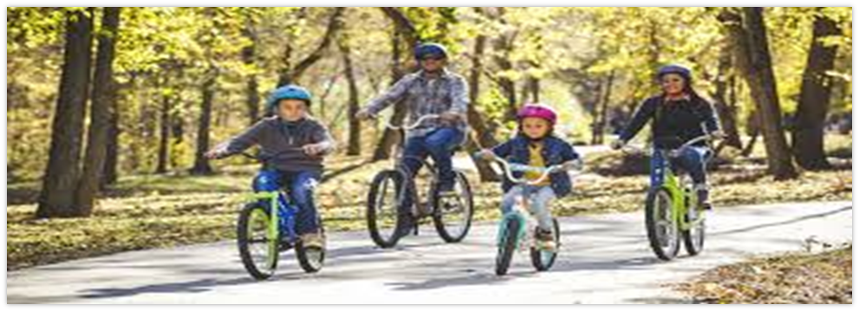
Picture 1. Riding bicycle

Task 3 Previewing using titles and headings
3.1 Directions: Here are the titles of books and the possible contents. Read and match them.
Contents
- Inter-group Relations
- Getting Message Through
- Artificial Human Organs
- Research (riset)
- Fixed Assets
Titles
- The Internet: Instant Reference (b)
- Scientific Method (d)
- Social Psychology(a)
- Fundamentals of Accounting(e)
- Understanding Biotechnology (c)

3.2 Directions: Read the following titles or headings and write down the likely content of each book or article. Compare your work with your friend’s.
“Understanding Statistics for College Students”
= calculus, sample survey method, data, the definition of statistics, basic statistics
“English for Business”
= Public speaking, writing and reading, expressions for presenting, marketing, communication for international business, negotiating
“How to Perform Well in An Interview”
= skills, motives values, attitude, how to dress, how to answer the questions
3.3 Directions: Which of the following book would you consult if you were studying how new technology influence human behavior? Study the subtitles. Then, give reasons for your choice.
- Violence. The Effect of Hi-Tech Media
- Internet. The Way to Create Webster
- Living in Foreign Countries. Problem with the Cultures //tinggal di negara asing. Masalah dengan budaya//
- Modern Technology. Several Discoveries
- Computers for the Workers. How do they affect you?
The reasons:

Task 4 Previewing Using Graphs and Illustrations

4.1 Directions: Look at this diagram and predict what the accompanying text is about.

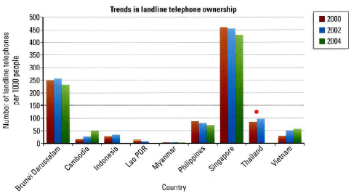

Prediction: Mortality rate/crime cases/poverty ratenational revenue/newborn baby rate.
The diagram chart is about: The trend(perubahan) of mortality rate in Southeast Asia in 2000,2002, and 2004

4.2 Directions: Look at the pictures below and try to predict what the text is about. What kind of text do you think it is?
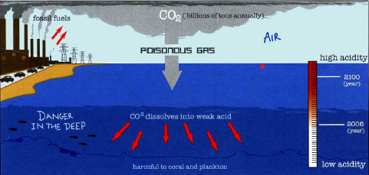

About carbon cycle( siklus karbon) where is the air pollution from factory smoke produces poisonous gas, thereby affecting the level of ocean acidity. If the acidity of the sea is not good, it will cause the fish and coral reefs will die. Besides that, the water of ocean that used by human will cause disease. (Terlalu spsific heheee) the right is...
- How poisonous gas which is caused by fossil fuels will affect the sea creatues
- How air polution affect water and marine ecosystem in the sea
- The process of how...
Gas: factory emissions

Previewing a Short Passage
When you preview a short passage, here is a process that you can follow:
- Read the title.
- Look at the pictures (if there are any).
- Read the first few sentences in the first paragraph.
- Read the first line of the other paragraphs.
- Read the last sentences of the last paragraph.
- Watch for names, dates, and numbers.

Task 5
Directions: Now, read the following passage and answer the question that follows.

Do Pigeons Take the Train?
Pigeons are smart birds. They are good at finding places. They can find their way home from many miles away. Scientists are not sure how pigeons know their way, but they do. They almost never get lost.
Can pigeons find their way under the ground? Some underground passengers in London say that they see pigeons on the Underground trains. Rachel Robson says she saw a pigeon at the Paddington Station. It got on the train and then got off again at the next stop
Some train lines are especially popular with pigeons. They are often seen on the Northern and Picadilly lines. Lorna Read also sees pigeons at the Paddington Station. Once, a passenger tried to get a pigeon off the train. The pigeons flew back in just before the doors closed. It seemed all upset like a person who doesn’t want to miss the train.

Why do pigeons get on trains? ome people say that the pigeons are not looking for food. They say the pigeons want to save time. London is a big city. The pigeons get tired of flying and they do what people do. They take the train. What do the scientists think of this? They say they must have some more information anything is possible with pigeons.

- What is the passage about? About pigeons. Do pigeons take the train? Because many people see the pigeons at the station
- What do people see on underground trains? Pigeons
- Do they really take the train? Nooo. Pigeons just stays on the train not take the train. The scientists say that they must Yes because some people say that the pigeons want to save time bcs london is a big city so if the have some more information anything is possible with pigeons
- Do they like the sound of the train or do they like to hike to save time? Some people say they like to hike to save time
- Make other predictions about the passage. Then, read the whole passage at the end of Unit 2. Did you make good predictions?

- Predicting
Predicting is a strategy that involves the ability of readers to get meaning from a text by making informed predictions. Good readers use predicting as a way to connect their existing knowledge to new information from a text to get meaning from what they read. One of the techniques used in predicting is skimming. Skimming involves reading quickly to get the main idea of a text. To do this technique, you can read the topic sentences (usually in the first sentence of a paragraph) to understand the main idea of the text.
Task 6 Predicting the Next Idea
Directions: Read the sentence, and then tell which idea comes next.

- One hundred years ago, the British Empire was very large. The British sent ships and soldiers to North and South America, Africa, and Asia. They were British ships all around the world. The British were proud of this. They liked to say, “The sun never sets
  - In England.”
  - In our hearts.”
  - On the far side of the world.”
  - On the British Empire.”
- In some cowboy movies, the cowboys are all either good or bad. The good cowboys are great men who help everyone. The bad cowboys are robbers and killers. But in real life, most cowboys were just like all other men – not all good or bad. The idea of cowboys we get from the movie is
  - Very true
  - Not true
  - Good
  - Helpful
- On average, Americans move to a new home every seven years. However, some Americans never move. They live all lives in the same place. So there must be other Americans who
  - Move to new homes
  - Move very often
  - Never move
  - Move every seven years
- Some people say that it’s harder to learn things when you get older. They say your brain doesn’t work as quickly. That is why they sometimes say, “You can’t teach
  - A young dog anything.”
  - An old dog new tricks.”
  - A young dog new tricks.”
  - A dog when you are young.”
- The Potato Famine happened in Ireland in the 1840s. The Irish people were poor. They couldn’t buy meat or bread because they were too expensive. They ate mostly potatoes. Then a disease killed many of the potato plants. With no potatoes to eat, the people
  - Were happier
  - Ate meat instead
  - Died of hunger
  - Were ill

Task 7
Directions: Read the following text, the predict what the book is about. Give evidence.

Preface to Second Edition
…the emphases within the field of social psychology have altered very radically. The focus is presently much more on social cognition: that is the way in which social events are stored in memory and used subsequently to determine social behavior. This focus has been more clearly represented in the new edition with clear explanations of such concepts as schemata and scripts, social representation, and social society…
= about social cognition that has been more clearly represented in the new edition.
The evidence is the text explain about the way in which social events are stored in memory and used subsequently to determine social behavior, this is a social cognition.

Task 8
Directions: Read the following text then predict what the books are about. Give evidence for your answer.

- Although researchers have formally discovered and named language learning strategies only recently, such strategies have actually been used for thousands of years. One well-known example is the mnemonic or memory devices used in ancient times to help storyteller to remember their lines. Throughout history the best language practice techniques to analytic, rule-based strategies.
= About languange learning strategies

- Rupert Bear woke one morning feeling in just the mood for an adventure. So after breakfast, he asked his mother if he could spend the day in the hills. Mrs. Bear wasn’t very sure at first, but in the end, she agreed. “Now, remember to keep well wrapped,” she said, tying Rupert’s scarf around his neck. “We don’t want you to catch a cold, do we?”
= Rupert Bear adventure to the hills with agreement from his parents
Evidence: After rupert bear asked to his mother, she is agreed with condition that rupert bear must always war his scarf to keep warm.

- As a foreman Taylor soon realized that under the existing system of initiative and incentive, the greater part of the responsibility for getting the work done is left to the workers, whereas he believed that all responsibility for planning and arranging work should rest with the management, leaving the doing of it to the worker. This involved a complete change in attitude, a ‘mental revolution’, on the part of both workers and managers
= the responsibility for getting the work done is left to the workers / mental revolution for responsibility of workers
Evidence: in the text explain that foreman and workers have different responsibilities for planning and arranging work. This involved a complete change in attitude, a ‘mental revolution’, on the part of both workers and managers

- As in other exercises, do not practice it when you suffer an acute illness like influenza or diarrhea. It is much better and certainly safer to resume practice after your recovery. Although you do not require any special equipment, you should always use a pair of flat-soled shoes during practice to avoid injury to your soles. A soft, loose, sweat-absorbing shirt and a loose, baggy pants will be an asset as they permit free movement.
= comfort in exercising
Evidence: in the text explained how to dress while exercising and when we can do the exercise when we are get sick.
- What makes a stew? Technically, stewing is a method of simmering meats (or fish or fowl), usually cut in small chunks in liquid which may be water, wine, beer, or broth. In the old days, stews were kept at the back of the stove, simmering ever slowly and changing somewhat from day to day depending upon whatever garden or barnyard provided.
= Stewing method
Evidence: in the text explain about stewing method
- Party power was further eroded with the emergence of the concept that democracy was best served not by party representation but by the representation of the functional social group. In the 1960 parliament, 129 members were appointed to represent the parties.
= the concept that democracy was best served not by party representation but by the representation of the functional social group.
Evidence:

- Scanning

Scanning is a quick reading for the purpose of locating specific information. When you learn to scan you do not have to read every word to get information. Scanning is also used to help you sample any text and decide whether the text is suitable for you or not.
When you need information from a newspaper or a book you do not need to read the whole book or newspaper. In the same way, if you need your friend’s telephone number from a telephone directory, you do not read the whole book. You read only what you need.
You usually scan:
A telephone directory
Schedules
An index in a textbook
A list of movies in a newspaper
The pages of a dictionary
Graphs
Tables, etc.

You usually do not scan:
A mystery story
A textbook for an important course
Important papers from a lawyer
A map to getting to a place
Question on a test

Example:
Read these questions and answer them as quickly as you can, based on the information at the end of this unit. The teacher will time you to locate the answer.

- What does three-star mean?
- Who can attend an X-rated movie?
- What is the Movie Industry Rating for The Gate?
- Are there any X-rated movies listed?
- Is Kangaroo a good film for children?
- Is Project X an excellent movie?
- Where you can see Cutter’s Way?
- Where is Raising Arizona being shown?
- How many theatres are showing Blue Velvet?
- How many of the films listed are considered excellent?

You do not have to read every word to answer the question. You also do not have to understand every word. In the following tasks, practice scanning. Read only to find the answers to the questions. Try to work fast. The teacher will time you.

Task 1 Scanning an Index

Directions: Scan the following index from a textbook, which is at the end of this unit, and then answer the following questions. The teacher will time you.

On what page (s) can you read about:

- Confidentiality
- Cognitive model of bystander intervention
- Bogardus, E.S.
- Client-centered therapy
- Darwinian theory
- Deception
- Cause and effect
- Culture
- Byrne D. and Clore G.L
- Contact hypothesis

Task 2 scanning a Newspaper Ad
Directions: Scan the following ad from a newspaper, which is at the end of this unit, and then answer the question. The teacher will time you.

  - How much does a gentlemen’s leather wallet cost? _________________________________
  - Which health farm has been running for more than 20 years? _________________________
  - Where you can buy handicrafts from Bulgaria? ____________________________________
  - You buy something from Helen Trist. What is it made of? ___________________________
  - You want to buy a sewing machine. How much discount do you get if buy it from Sewcraft Sewing Machines, Ltd. _______________________________________________________
  - What address would you write to if you want to buy some baby clothes? _______________
  - Where do you go to have beautiful nails? ________________________________________
  - Which town can we go to buy imported Japanese silk macintoshes? ___________________
  - Whom should I write to for relaxation therapy? ___________________________________
  - Which company dyes your household linen? ______________________________________
Task 3 Scanning a Newspaper Story
Direction: Scan this newspaper story to find the answer to these questions

  - How many people died in the typhoon? _____________________________
  - On what day did the typhoon begin? __________________________________
  - How many people lost their homes? ________________________________
  - What is the name of the island that was hit worst? _____________________
  - What is the name of the typhoon? __________________________________
  - How many people are missing? ___________________________________

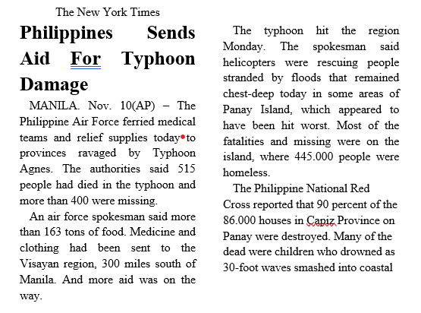
Task 4 Scan a Short Passage
Directions: Study the following questions, and then find the answer by scanning the following text.
- What kind of crab is in this partnership?
_____________________________________________________________________________
- How is its partner described?
_____________________________________________________________________________
- Where does the crab partner live?
_____________________________________________________________________________
- Why does the sea anemone gain?
_____________________________________________________________________________
- Why does the crab gain?
_____________________________________________________________________________
- What is the ‘two gun’ crab protected by?
_____________________________________________________________________________

- In the crab–anemone relationship, the two animals
  - Both profit while living together
  - Work together only now and then
  - Try to harm each others
  - Each use tentacles against enemies
A hermit crab that has found an empty shell for its new home may share its dwelling. It chooses a sea anemone to settle on top of the shell. This flowerlike animal’s usual home is on a rock.
The sea anemone gains by partnership. As it rides in the shell, it has a better chance of getting food. Pieces of food torn by the crab as it dines may also reach anemone’s mouth
The crab profits in its turn. Its enemies find the crab harder to see and to attack. Around the anemone’s mouth are tiny arms called tentacles. These shoot out threads that poison and even kill.
A hermit crab sometimes becomes a “two-gun” wanderer. It carries an anemone on each of its first pair of legs.

Task 5 Indication Exercises
Directions:
a. Scan each line and circle the word that is different. The teacher will time you. So, work fast!
Example: our our own our our
  - new new new now new
  - is in is is is
  - my my my by my
  - me me me my me
  - our one one one one
  - him him him him his
  - had had did had had
  - may may my may may
  - these these there these these
  - when then when when when

- Work at top speed. Read the key and scan the line. Circle the keyword every time you see it.
  - into onto unto until into intro into
  - been been bean born been bane been
  - back black bark back back book both
  - must much mush mist must mash muse
  - then them then thin then their then
  - way way why wax way wry way
  - out our out oust our out own
  - all all ail aim all owe alm
  - with witch with wish will with wilt
  - over ever over aver our out over

- At the left vertical line, there is a word. Read across the line as fast as you can. Circle the one that has the same meaning as the word at left.
  - bike car bicycle book train person
  - easy ready short simple daily ready
  - try begin attempt show die cry
  - cry say tell shout love hope
  - boat ship sheep mice price mile
  - road sea street trip shop view
  - middle north west south east centre
  - middle entire few no many some
  - whole entire few no many some
  - buy send bend keep purchase walk

- Read the key phrase. Scan and circle the keyphrase every time you see it.
  - Key phrase: after class
After math…..…after class....….under class..…...other class..…...mother’s class……..after closing….….math class….….after class….….other math……..after class……..after the course……..under course……..after class.
  - Key phrase: rent a movie
Sent a movie……..rent a car……..sent a note……..rent a movie……..rent a tape……..sent a movie……..like a movie……..rest a while……..rent a van……..rent a movie
  - Key phrase: across the street
Across the road……..across the aisle……..under the street……..across the street……..across the screen……..across the bridge……..acorns in trees……..across the street……..after the treat……..across the street

